How do you pass parameters to the Action Methods in Web Api

public void Delete(**int id**) : This will be passed as a Route Para

public void Put(**int id, Student student**) , Here id will be passed as Route Para

Stduent will be passed as a body

public void Post(**Student student**)

public Student Get(**int id**)

Parameters are either passed in Body or they are passed as Route Para or as a queryString

By def , primitive types(int, char, float, bool) are passed as Route Para / QueryString

Complex Types are passes as Body

//public void Post([FromBody] Student student)

//{

// students.Add(student);

//}

By def , Student object will be passed as body

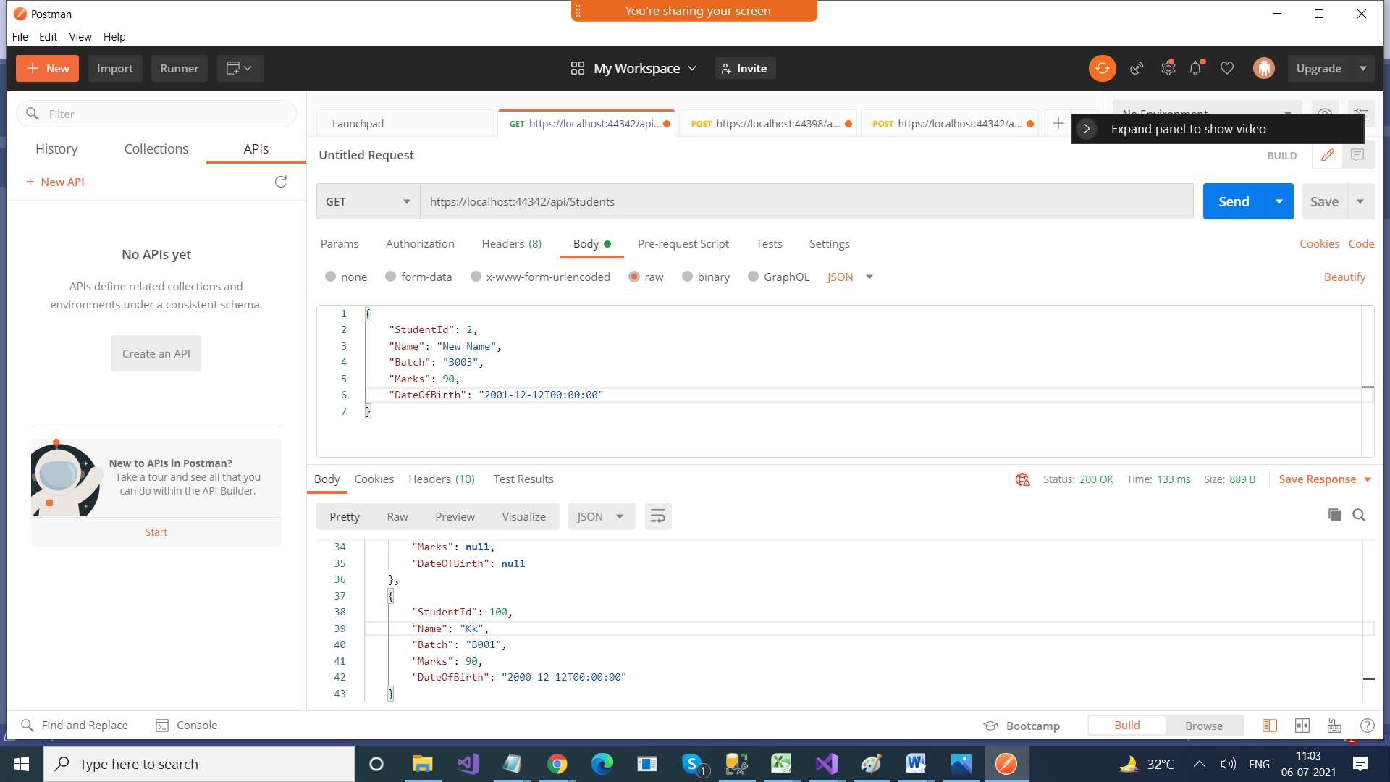

--------------------

Now , if you want to pass Student object as a Route Para, use [FromUri]

public void Post([FromUri] Student student)

{

students.Add(student);

}

<https://localhost:44342/api/Students?Studentid=100&Name=Kk&Batch=B001&Marks=90&DateOfBirth=12/12/2000>

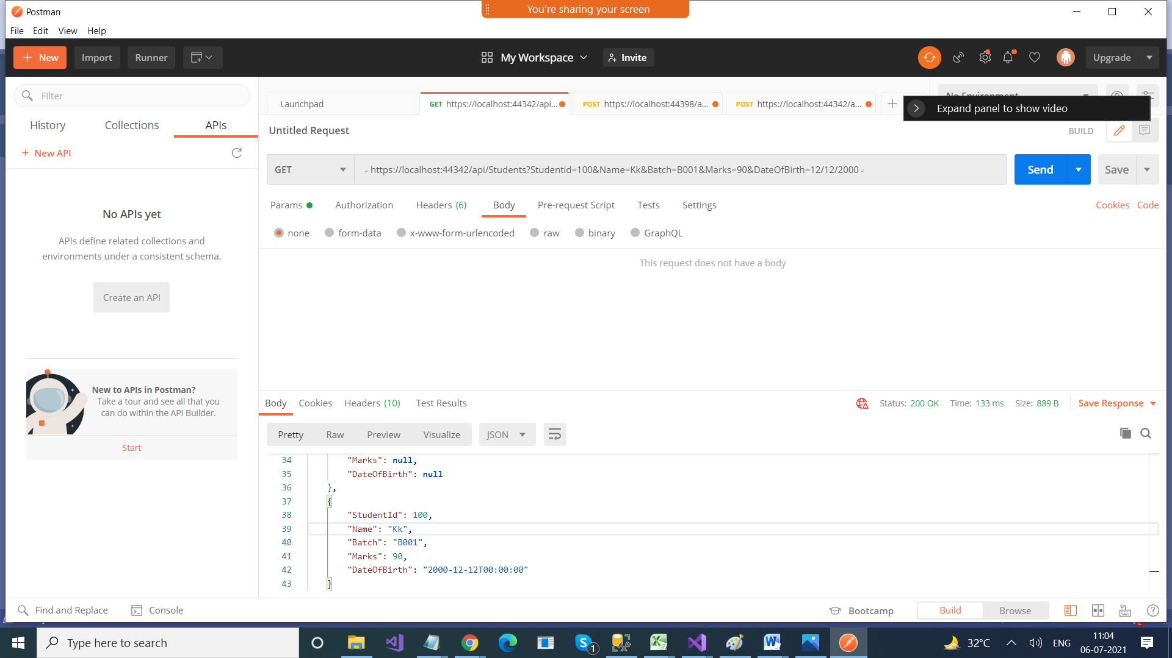

public Student Get([FromBody] int id)

{

return students.FirstOrDefault(x => x.StudentId == id);

}